Tristan Izlar

COP2360 C# Programming I

## Module 2 - TUTORIAL 4-6: Creating the Time Zone Application

SCREENSHOT:

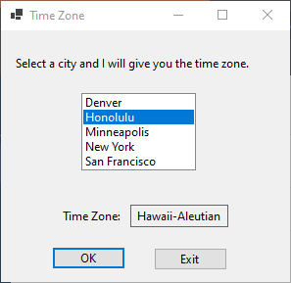

CODE:

using System;

using System.Collections.Generic;

using System.ComponentModel;

using System.Data;

using System.Drawing;

using System.Linq;

using System.Text;

using System.Threading.Tasks;

using System.Windows.Forms;

namespace Time_Zone_Application

{

public partial class Form1 : Form

{

public Form1()

{

InitializeComponent();

}

//Exit Button

private void exitButton_Click(object sender, EventArgs e)

{

this.Close();

}

//Ok Button

private void okButton_Click(object sender, EventArgs e)

{

//variable declaration

string city;

//if-else statement to check user selection

if (cityListBox.SelectedIndex != -1)

{

//set city equal to the selected list item (as a string)

city = cityListBox.SelectedItem.ToString();

//switch to supply the time zone description for the selected city from the list

switch (city)

{

case "Honolulu":

timeZoneLabel.Text = "Hawaii-Aleutian";

break;

case "San Francisco":

timeZoneLabel.Text = "Pacific";

break;

case "Denver":

timeZoneLabel.Text = "Mountain";

break;

case "Minneapolis":

timeZoneLabel.Text = "Central";

break;

case "New York":

timeZoneLabel.Text = "Eastern";

break;

}

}

else

{

//prompts the user to select a city if they didn't

MessageBox.Show("Select a city.");

}

}

}

}

# //Collaboration Statement: I worked alone.